PROCEDURES for REGISTRATION TOLC AND ENROLLMENT AT TOR VERGATA
http://ing.uniroma2.it/2019/04/11/tolc-i-a-a-2019-2020-prove-per-accedere-ai-corsi-di-laurea-di-ingegneria/
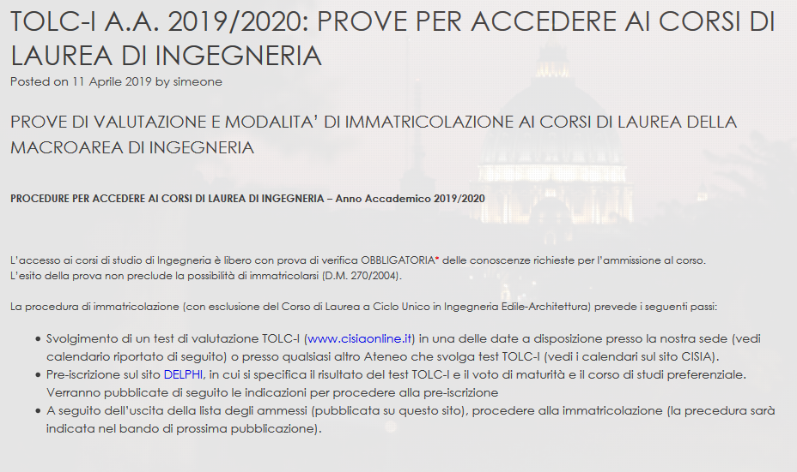

https://delphi.uniroma2.it/totem/jsp/aS_1_1.jsp?opzione=1&language=IT


